Step 1: What $Wx+b$does (before activation)
$$z=Wx+b$$
Geometrically, this:
- Draws a straight line (2D)
- Or a plane / hyperplane (higher-D)
This line splits space into two halves, but it’s rigid.
No curves. No bends. No tricks.

Step 2: Activation function = shape changer
Now we apply:
$$y=f(z)$$
This is where non-linearity enters.
1️⃣ Bent — Sigmoid
$$f(z)=\frac{1}{1+e^{-z}}$$
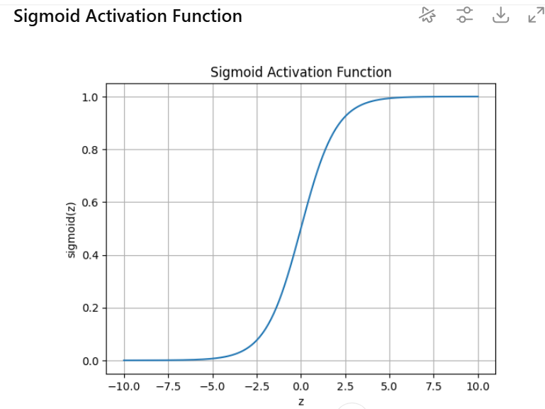
What it does mathematically:
- Squashes large negative values → near 0
- Squashes large positive values → near 1
- Smooth transition in between
What it does geometrically:
- Turns a flat plane into a curved surface
- Nearby points can separate gradually
📉 Think:
A straight ramp turned into an S-shaped hill
Why this matters:
- Output is no longer proportional to input
- Combining multiple sigmoids = curved decision boundaries

2️⃣ Clipped — ReLU
$$f(z)=max⁡(0,z)$$
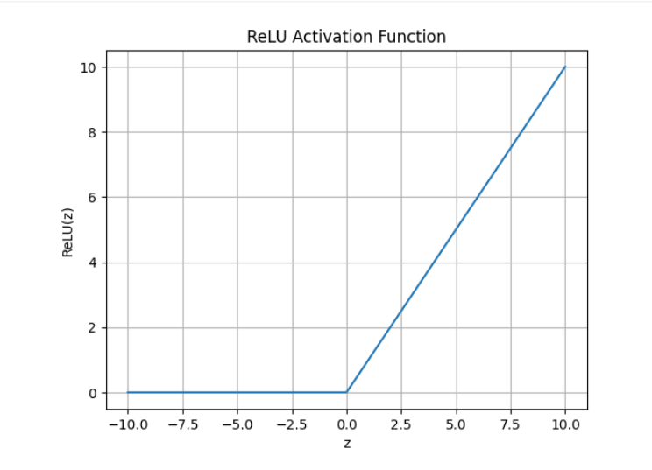
What it does mathematically:
- Negative part → cut off
- Positive part → unchanged
What it does geometrically:
- Space is split into two regions:
  - Dead region (all zeros)
  - Linear region (identity)

📐 The key:
ReLU introduces a corner at 0
Corners = non-linearity.
Stack many ReLUs → piecewise linear surfaces.

3️⃣ Thresholded — Step function
$$f(z)=\left\{\begin{matrix}1 & z≥0 \\ 0 & z<0\end{matrix}\right.$$
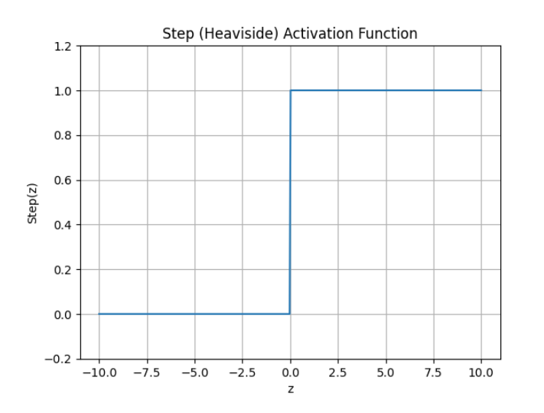
What it does:
- Hard yes/no decision
- Sharp boundary
Geometry:
- Space is discretely split
- No smooth transition
This was used in early perceptrons.

Step 3: What “each layer can now do”
This is the crucial insight.

🔹 Change shape
Before:
- Only straight lines
After activation:
- Curves (sigmoid)
- Bent surfaces (tanh)
- Folded regions (ReLU)
Each layer warps the space.

🔹 Create corners
Corners are impossible with pure linear models.
ReLU creates:
- A kink at 0
- A fold in space
Stacking ReLUs:
- Many kinks
- Complex shapes
This is how neural nets approximate any function.

🔹 Split space
Each activated neuron:
- Divides space into regions
Example with ReLU:
- One neuron → 2 regions
- Two neurons → up to 4 regions
- Many neurons → exponential regions
This is why depth is powerful.

XOR finally makes sense now
Without activation:
- Two lines collapse into one
- XOR impossible ❌
With activation:
- Hidden neuron 1 draws boundary #1
- Hidden neuron 2 draws boundary #2
- Output combines regions
✔ Space is split and recombined
✔ XOR becomes solvable

